   
 

**CIS 634 Object-Oriented Software Engr**

**Group 11**

**Secure Chat App Software Requirements Specification**

   
 

**2836088 – Abdul Rehman**

**2836430 – Tejam Reddy**

**2828837 - Varun**

**2837055 - Sravan**

**1.0 Introduction**

Hush Android chat app, which is a chat application used for personal and office purposes. A friend or office colleague can share any kind of private data through this application. It will help to chat with friends and office colleagues. Mainly, it will help people who want to hide their conversation. Privacy is the top priority of this application. Languages that have been used are Java and XML, developed in Android. Android studio is the tool that is used for this chat application development.

**1.1 Goals and objectives**

The main goal of Hush is a secure messaging app featuring end-to-end encryption as well as the ability to encrypt your messages so no one can read them. You can safely text a friend or family member your personal details like banking info, phone numbers, health information, and much more

* Sign in or Sign up using your phone number
* One to One chat
* Encrypt and decrypt messages
* Preventing screenshots during chatting
* Firebase Real Time Chat Integration
* Group chat
* Status Updating Feature
* Beautiful Material Design
* Sweet and Clean animations
* Image Sharing

**1.2 Statement of scope**

Hush is an Android chat app, focused on individuals who have trouble following safely texting with loved ones and want to hide their conversation. It is developed in a Java and XML environment, The Main Features of the application.

* Dashboard
* Chat
* Profile
* Contacts
* Settings

**1.3 Software context**

The software is placed in a business or product line context. Strategic issues relevant to context are discussed. The intent is for the reader to understand the 'big picture.

This application is based on privacy and secure chatting among friends, family, and office colleagues. Different kinds of functionalities have been implemented to make sure the high ratio success of this chat app. Functions like encryption and decryption, Group chatting with security and easy use of the application are the important factors of this developed application.

**1.4 Major constraints**

* All database maintenance will be handled by the users, and it is available when the user needs it.
* Data is secure enough that no user can see the personal information of the other user.
* Data must be restored in any case of loss of data.

**1.4.1 System constraints**

* The Internet should be available to use this system.
* All the records of the User are stored in the Database.

**2.0 Usage scenario**

This section provides a usage scenario for the software. It organized information collected during requirements elicitation into use-cases. Use cases are descriptions of how users will perform tasks. The following are our systems use cases:

**2.1 User profiles**

* User

Users who are using this chat application will perform a different kinds of functions. Sending and receiving messages with full privacy are the main functions.

**2.2 Use-cases**

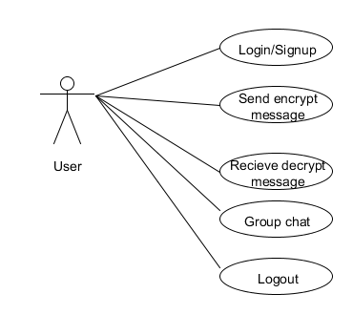

**3.0 Data Model and Description**

**3.1 Data Description**

An android application is developed with the privacy of data, and messages and provides full security using the real-time database. Every person can use this application as per need. This application provides some special functions like data encryption and decryption using different algorithms. A group chat option is available to chat in a group securely.

**3.2 Complete data model**

An ERD for the software is developed

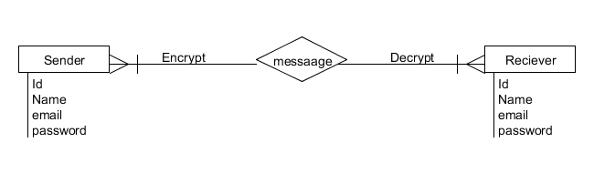

**4.0 Functional Model and Description**

A description of each major software function and software interface is presented.

**4.1.** **Description of Major Functions**

Each requirement is uniquely identified.

**4.1.1** User signup for the application by entering details.

**4.1.2** User should sign in by entering credentials.

**4.1.3** User update their profile.

**4.1.4** User must be able to send and receive messages

**4.1.5** Encryption of message should be available.

**4.1.6** Decryption of the message at the receiver end.

**4.1.7** Group chat should be available.

**4.1.8** The System must be reliable so that database should not go down and can handle it effectively.

**4.1.9** This system should be available 24 hours and provide services to the users when the user wants to access the system.

**4.1.10** Our product will be easy to use by anyone because its interface is not complex.

**4.1.11** System should give a quick response to user action.

**5.0 Restrictions, Limitations, and Constraints**

**5.0.1 Restrictions**

* Unauthorized users do not use this system.
* To use this system users will be registered first.

**5.0.2 Limitations**

* Android-based application
* Only firebase implemented specifications are usable
* Do not support cross-platform working

**5.0.5 Constraints**

* All database maintenance will be handled by the users and it is available when the user needs it.
* Data is secure enough that no user can see the personal information of the other user.
* Data must be restored in any case of loss of data.
* The Internet should be available to use this system.
* All the records of the User stored in Database.